Summary

Full Stack Architecture

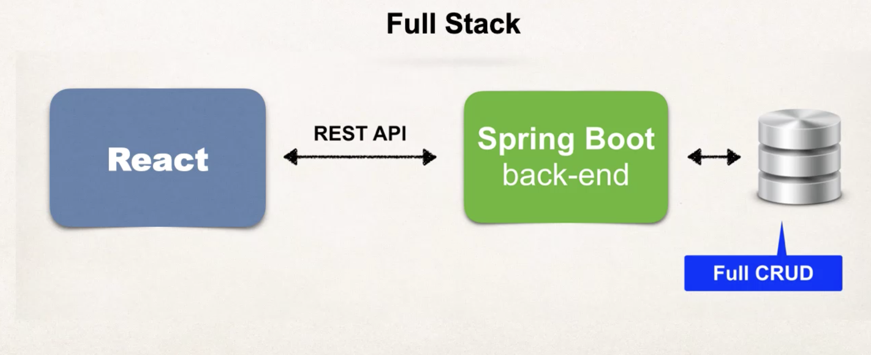

Use React as the frontend client application, which communicates with the Spring Boot backend through RESTful APIs. The Spring Boot backend manages all data operations, handling Full CRUD (Create, Read, Update, Delete) operations with the database and returning the processed data back to the React frontend.

VSCode: npm start

Start SQL server

IntelliJ -> run the code

Home Page

* Navigation bar
* ExploreTopBooks component
  + Add background picture using first <div>- ‘header’ – code from App.css
  + Format text using second <div>
  + Add text
* Carousel component
  + Title
  + Desktop
    - Carousel-item \* 2; one active; one without active
    - Two buttons: prev & next
  + Mobile
  + Child component: ReturnBook.tsx
* Heros component
  + Desktop
    - Col 6:4 picture:text
  + Mobile
    - Picutures and text -> arrange vertically
* Library services
* Footer
* Wrap up HomePage.tsx

Spring Boot Backend

* Create Repository
  + Spring Data REST will scan your project for JpaRepository  
    （Spring Data REST automatically scans your project to find all defined JpaRepository interfaces.）
  + Expose REST APIs for each entity type for your JpaRepository  
    （For each JpaRepository, Spring Data REST will automatically generate corresponding RESTful APIs. These APIs will allow you to perform standard CRUD operations (Create, Read, Update, Delete) on the entities.）
* REST Endpoints
  + Spring Data REST will create endpoints based on entity type
  + Simple pluralized form + first character is lowercase + add ‘s’  
    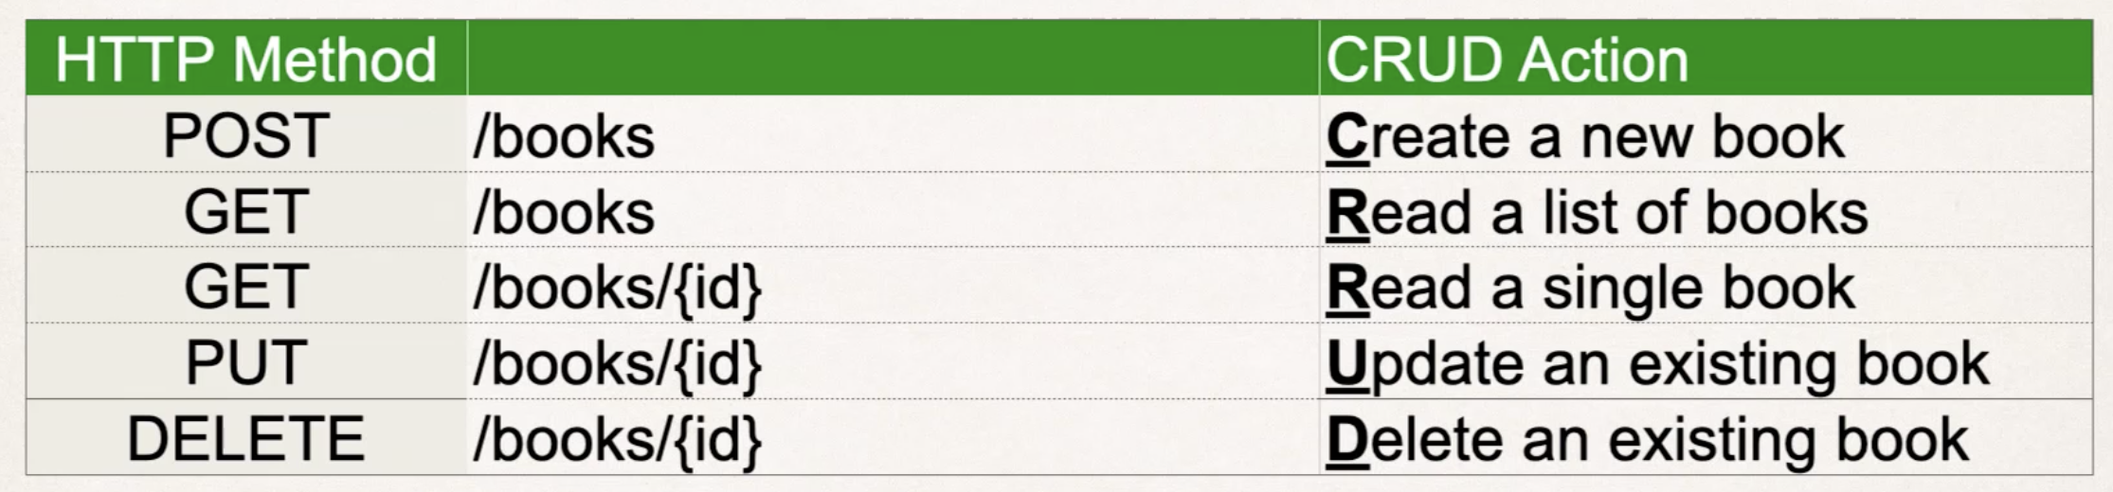
* Steps
  + Set up the database tables
    - Run 5 SQL scripts to upload the books, reviews, etc.
  + Create a Spring Boot starter project (start.spring.io)
    - When creating the project, add Lombok as dependencies.
    - Lombok: automagically generates the getters and setters behind the scenes.  
      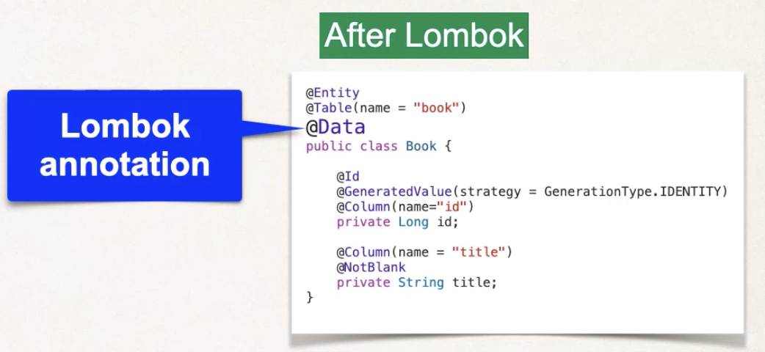
    - Dependencies:  
      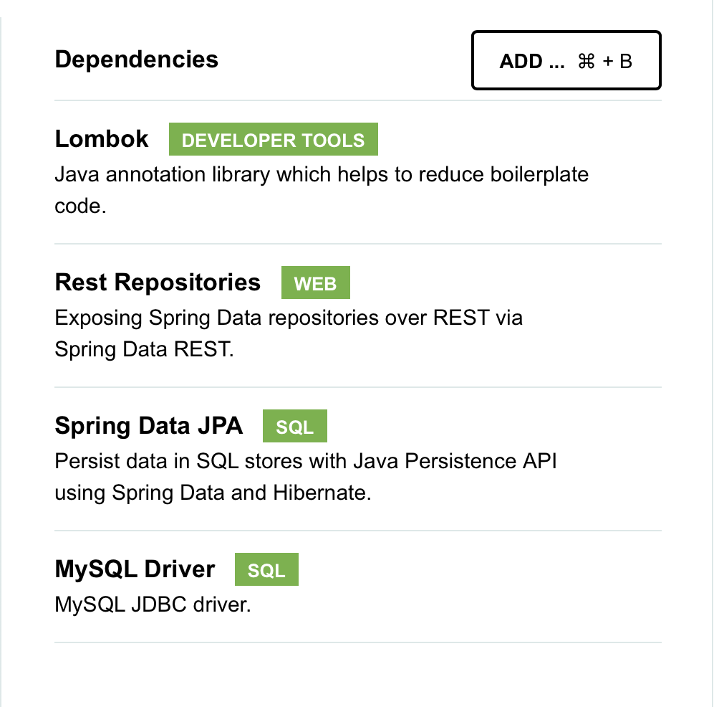
  + Develop the Entity: Book
    - @Entity: Marks the class as an entity class, making it correspond to a table in the database.
    - @Table(name = “book”): Maps the Book entity class to the book table in the database.
    - @Data: Lombok: Automatically generates standard methods for all fields in the Book class, such as getters and setters, simplifying the code.
    - @GeneratedValue(strategy = GenerationType.IDENTITY): Sets the id field's value to be auto-generated by the database.
  + Create REST APIs with Spring Data JPA Repositories and Spring Data REST
    - New package: dao
    - Configure to disable certain HTTP methods: POST, DELETE etc...
      * Create a new class MyDataRestConfig implements RepositoryRestConfigurer

React Frontend - Consume Carousel Book API - VS

* New folder under src: models -> BookModel.ts
* useState & useEffect
* fix carousel -> dynamic
* add spinner loading utils -> make the application more professional

React Search Book component

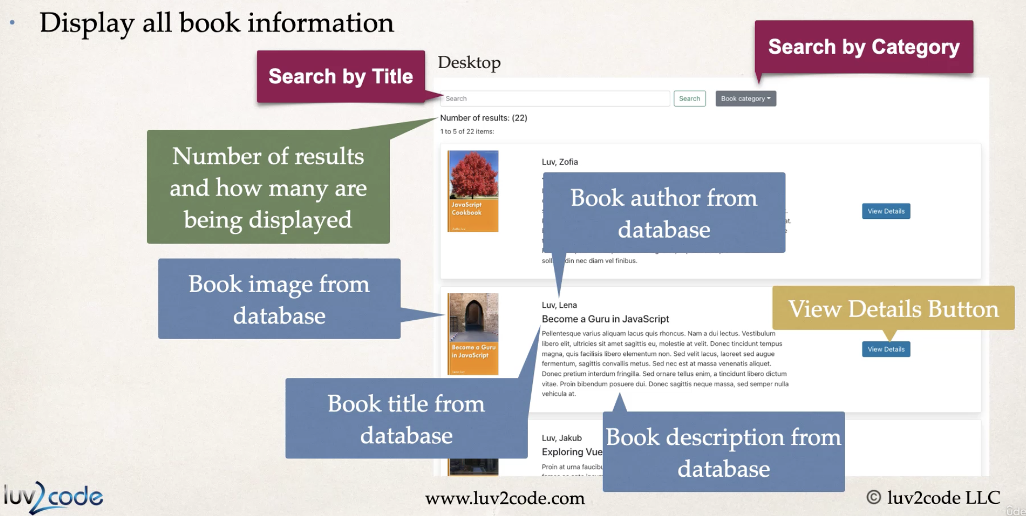

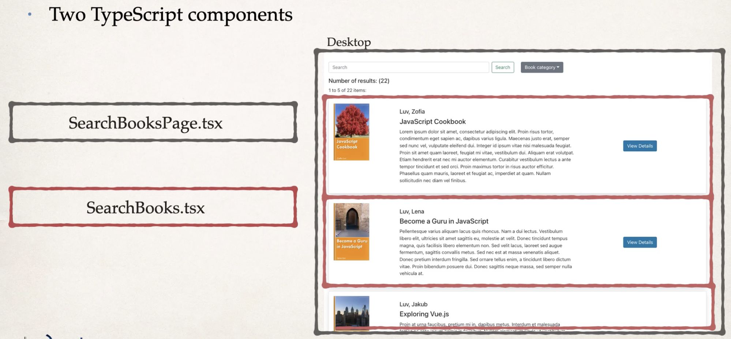

* SearchBooksPage
  + UseEffect, useState
  + React format and component
  + Call <SearchBooks>
* SearchBooks
  + Desktop & mobile
* Pagination
  + Pagination.tsx under Utils  
    
  + Backend Spring Boot
    - Spring Data REST
  + Frontend React
    - Apply pagination to SearchBooksPage
      * Add more useState
      * Calculate indices
      * Dynamic
      * Look for codes that have comment ”add for pagination”
* Apply search bar functionality
  + Search bar
    - Backend
      * BookRepository
      * Check with postman -> /search -> findByTitleContaining
    - Frontend
      * Add useStates
      * Change url variables
      * useEffect [] added searchUrl
      * added a function to handle search changes
      * oncClick & onChange listener
  + search by category
    - Backend
      * Similar to above
    - Frontend
      * Add useState
      * Add categoryField function
      * onClick listener
      * fix but by adding searchWithPage

React Routing

* app.tsx
* React-Router-dom -> Switch -> Redirect
* Make navbar work: Navbar.tsx
* Make all the links work

Book Checkout

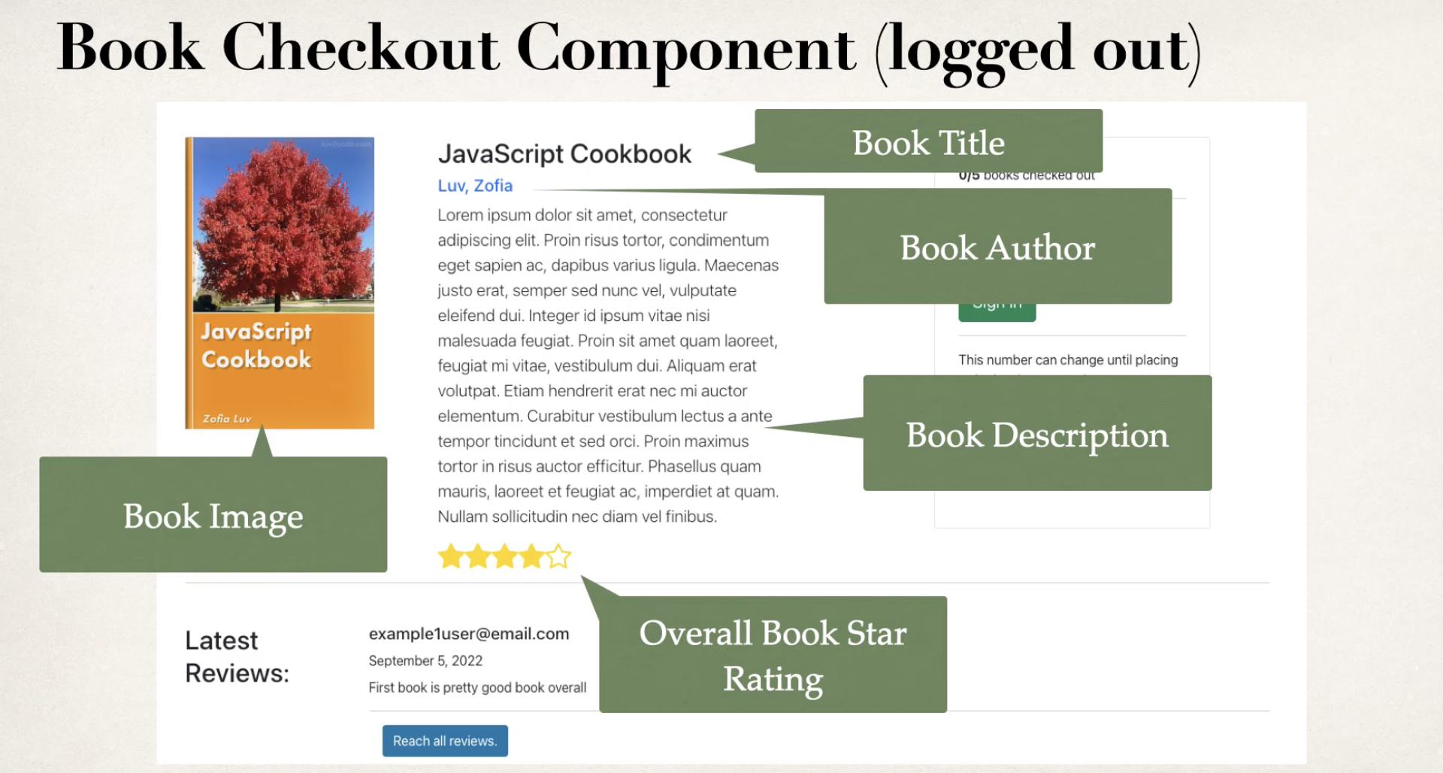

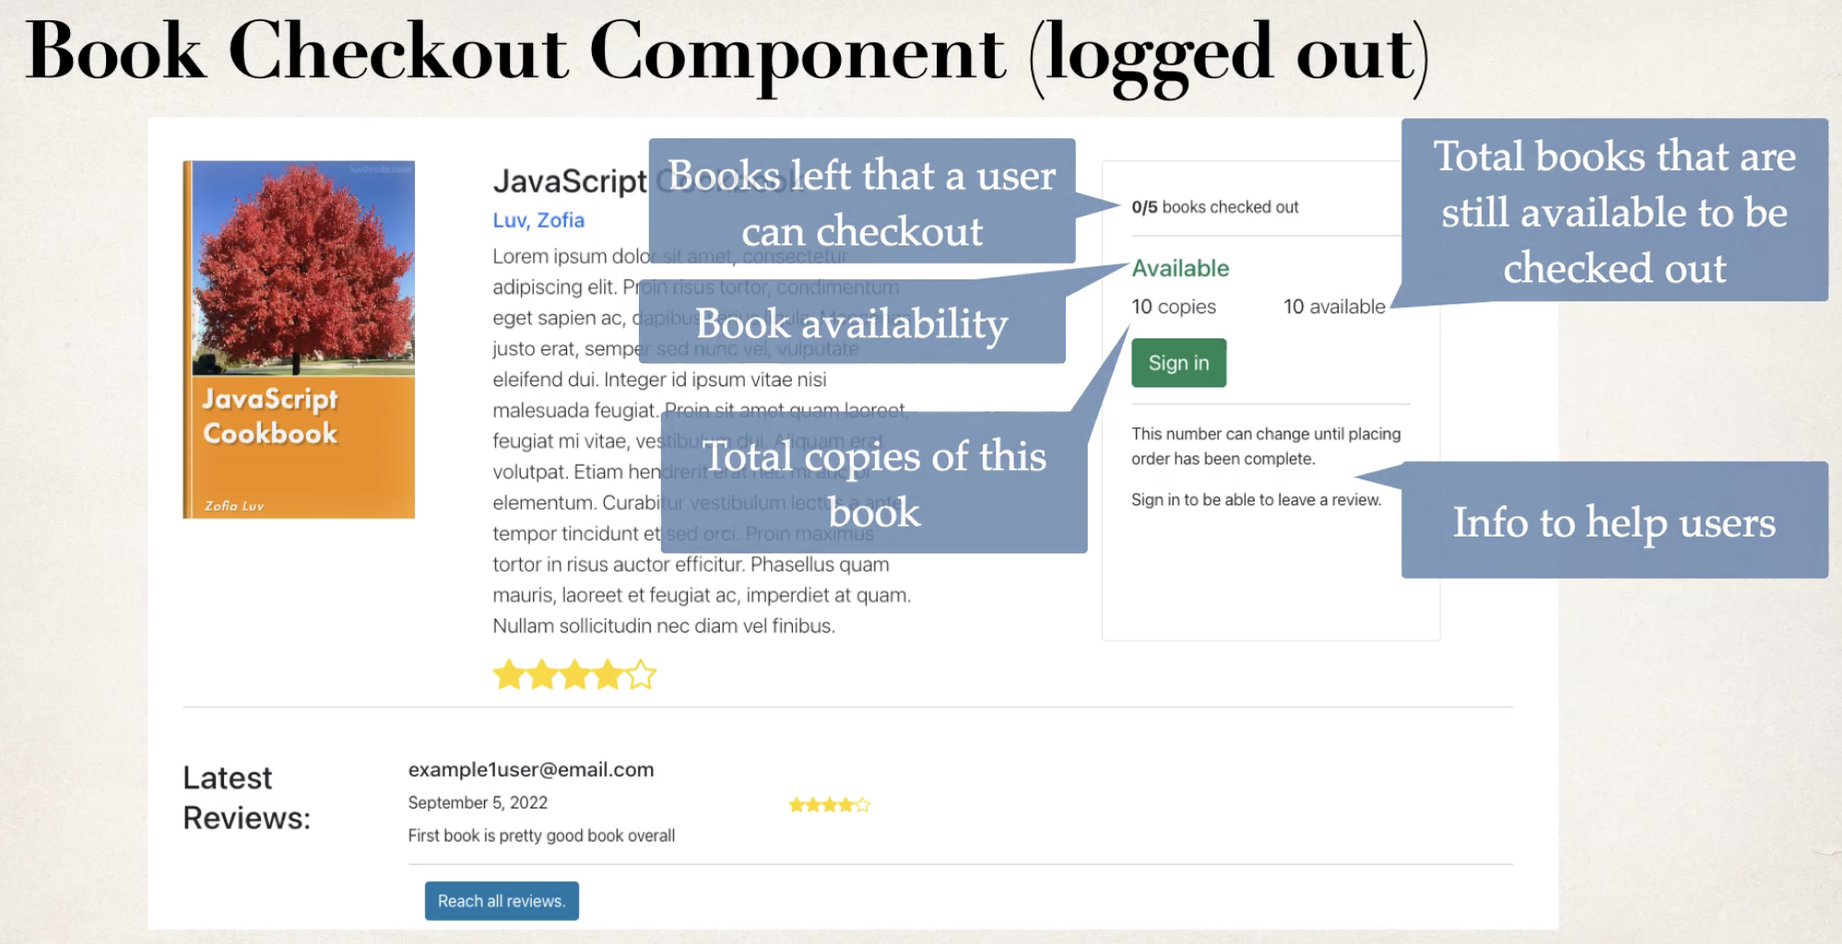

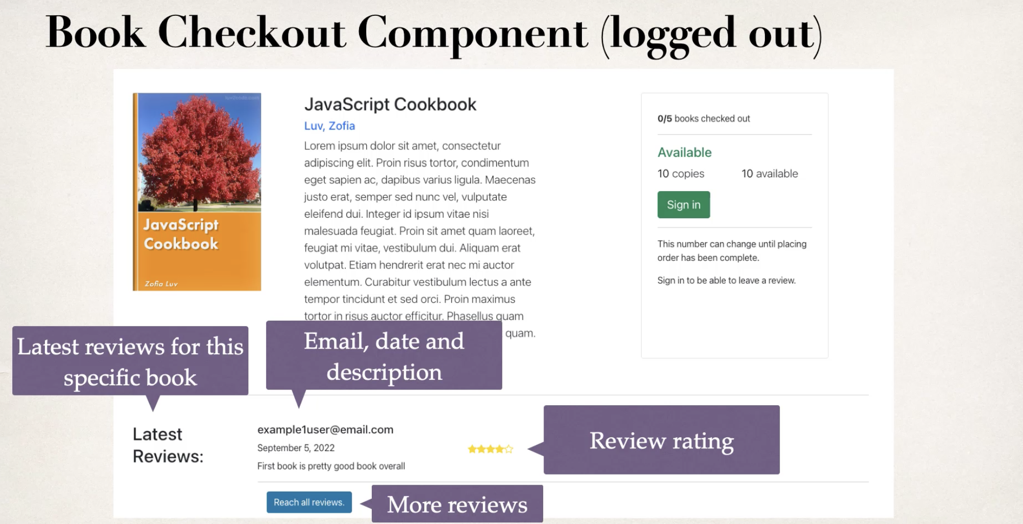

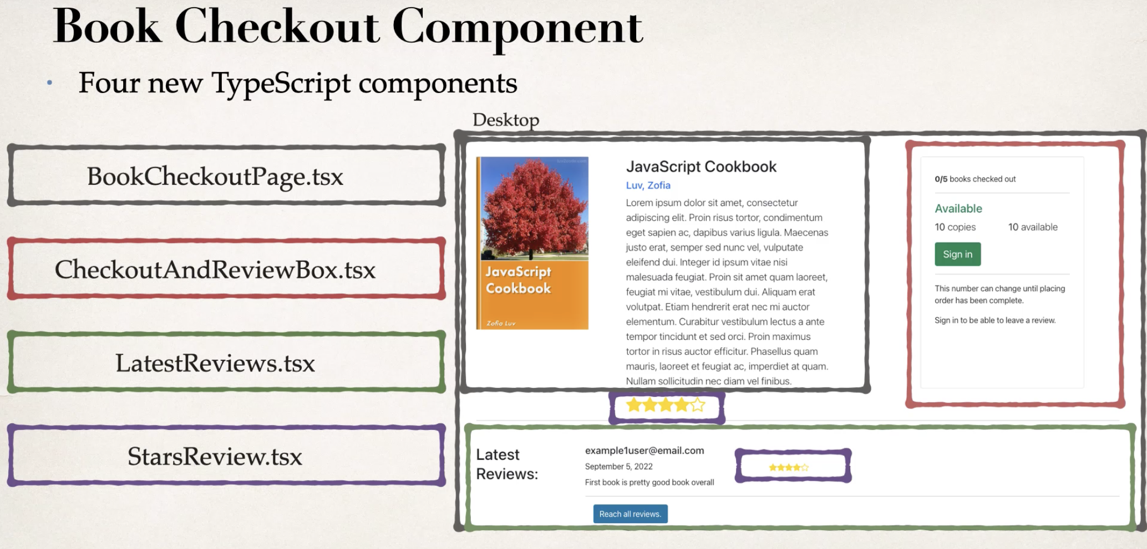

* BookCheckoutPage.tsx
  + Route
  + useState
  + useEffect -> modifications
  + frontend for desktop and mobile
* link search page and checkout page – SearchBook.tsx (anchor tag -> Link)
* Stars
  + Bootstrap 5 icons -> Utils -> change width and height with props
  + Add logic to break down ratings -> make the star dynamic
* CheckoutAndReviewBox.tsx
  + React frontend
  + Add to BookCheckoutPage.tsx

Reviews on Checkout Page

Spring Boot REST Endpoint

* Entity -> Review
* Dao -> ReviewRepository
* Add Id: MyDataRestConfig -> config.exposeIdsFor() add Review  
  However, still cannot find by book Id
* Add findByBookId to Review Repository

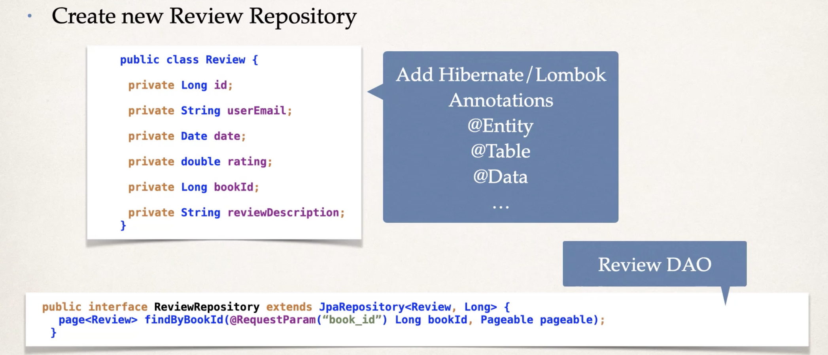

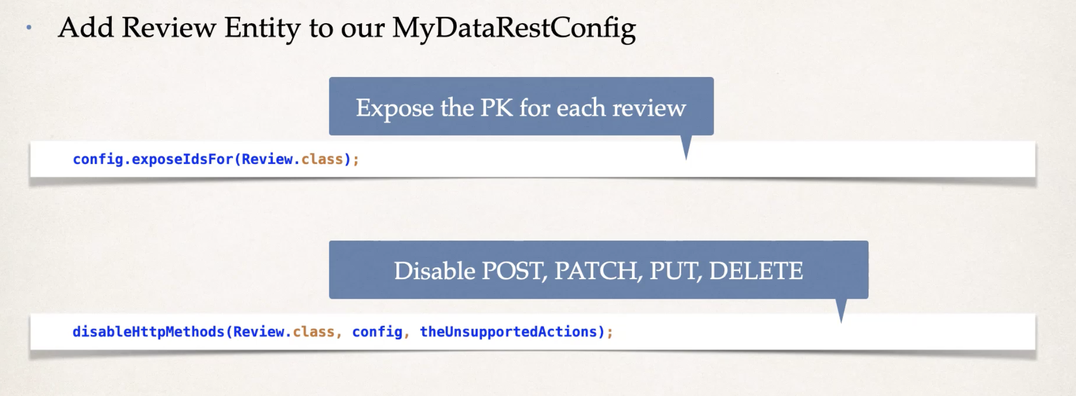

Frontend

* Models -> ReviewModel.ts
* BookCheckoutPage
  + Add states
  + Review useEffect
* LastestReviews.tsx
* Util -> Review.tsx
* Make stars dynamic -> replace 4.5 with totalStars

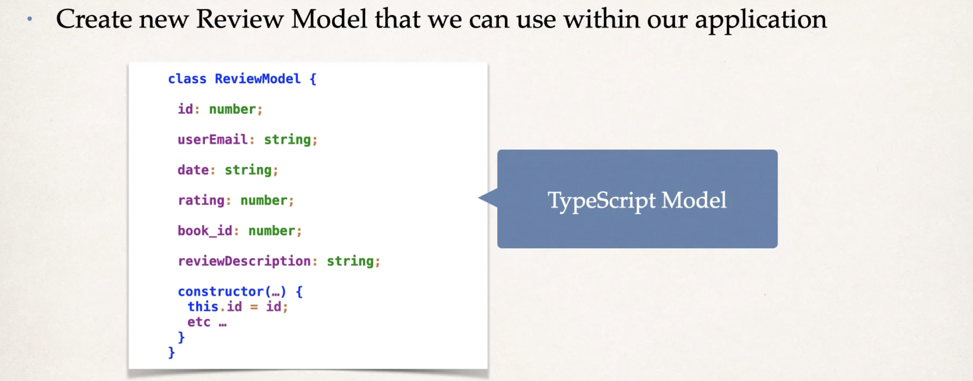

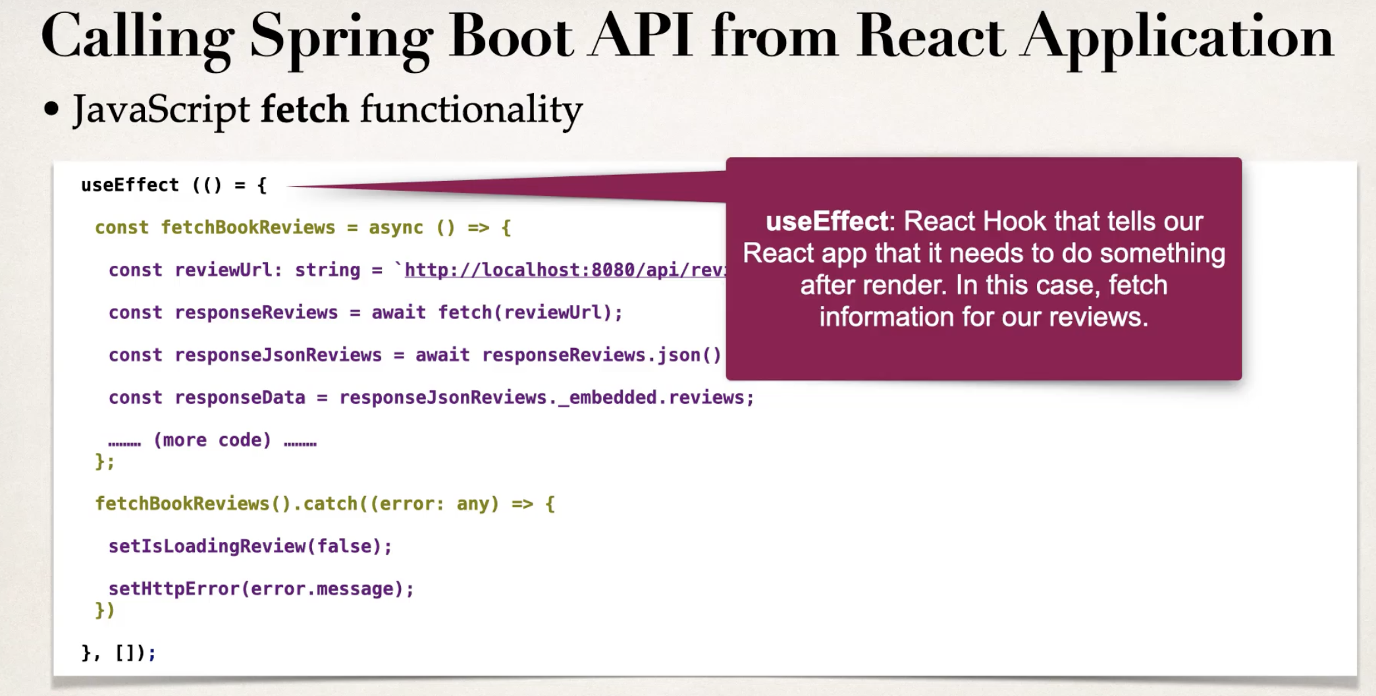

Authentication



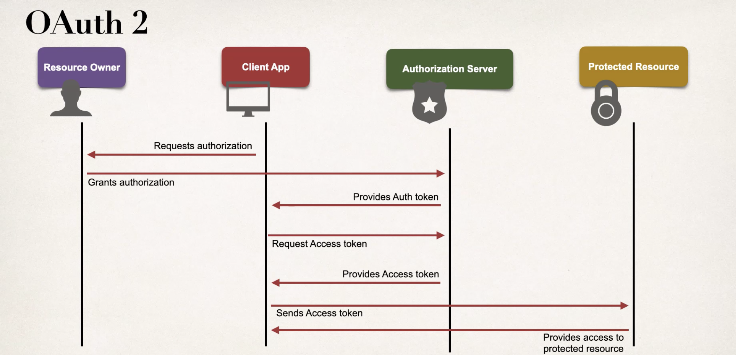

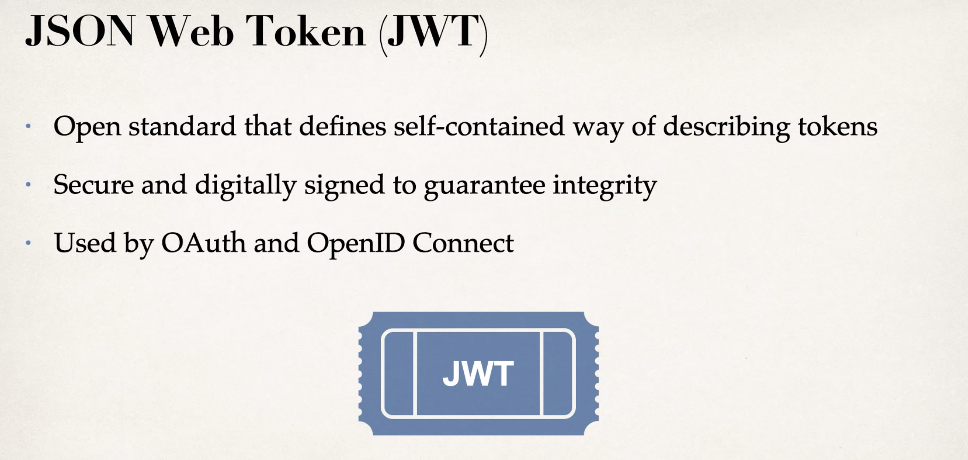

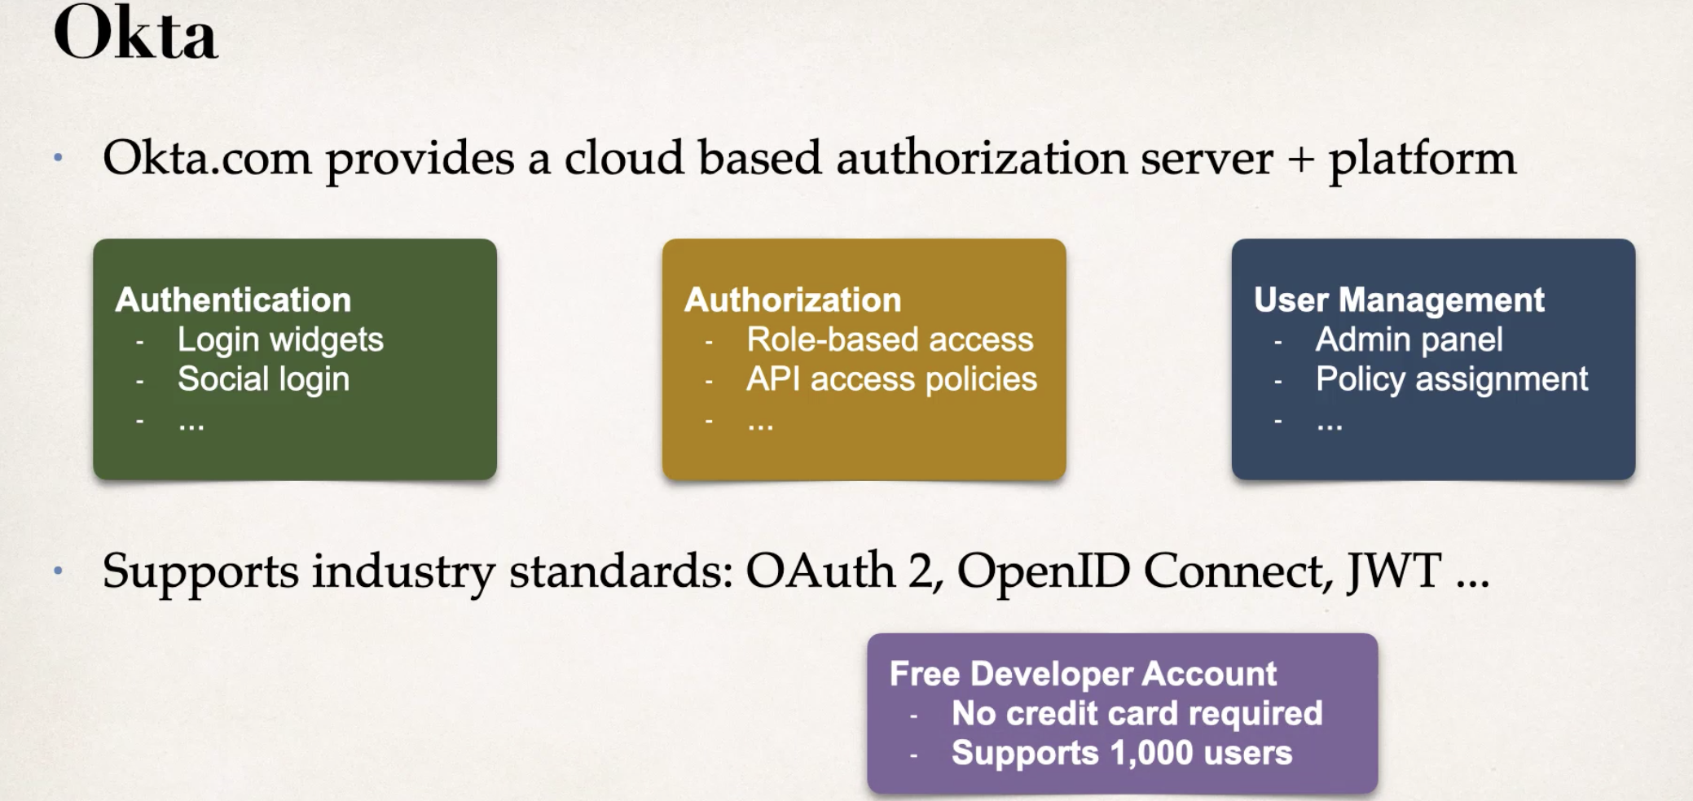

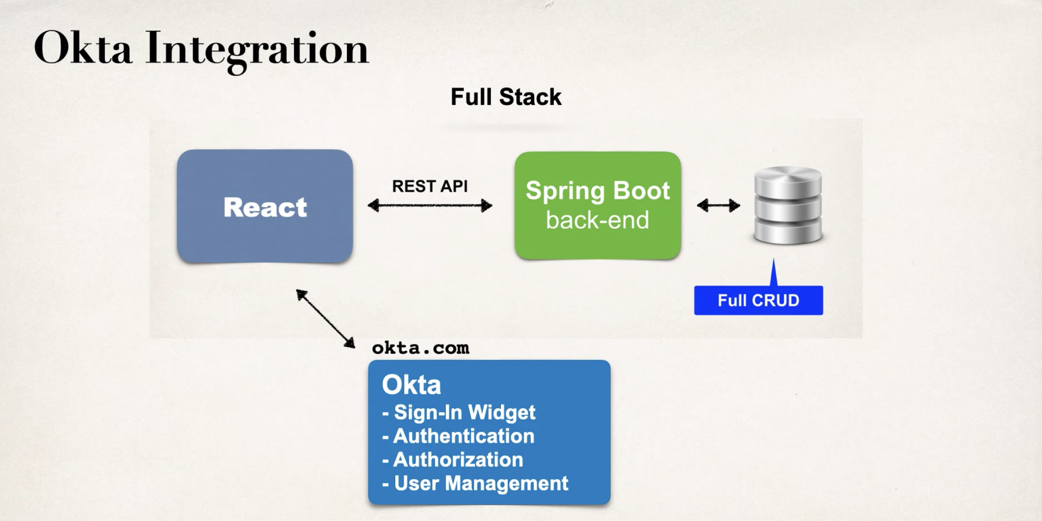

React Frontend

* Create a free developer account at okta.com
* Add OpenID Connect client app in Okta
  + In your Okta Developer Account, create a new application
  + Select option for:
    - OIDC: Open ID Connect > Single-Page Application
    - …
* Set up app configuration for OpenID Connect
  + Provide configs
  + clientId and issuer -> available on Okta application details screen
  + 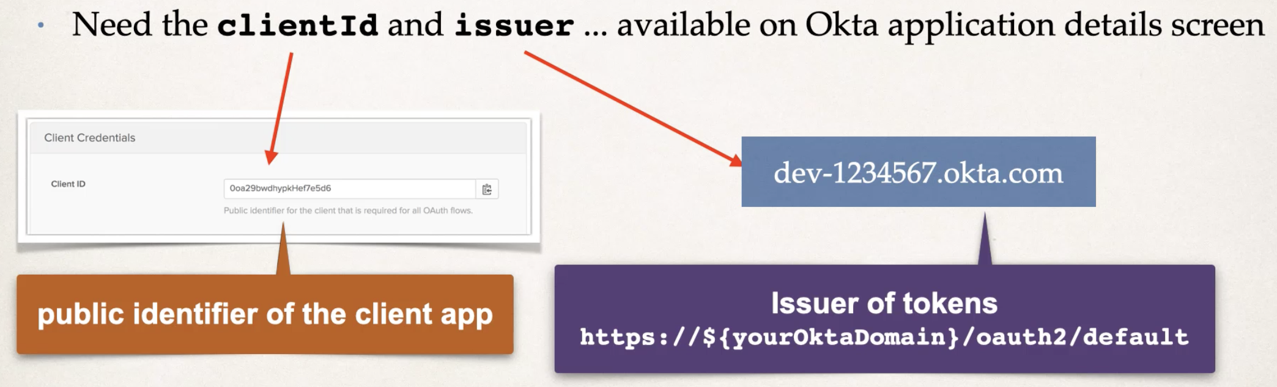
  + 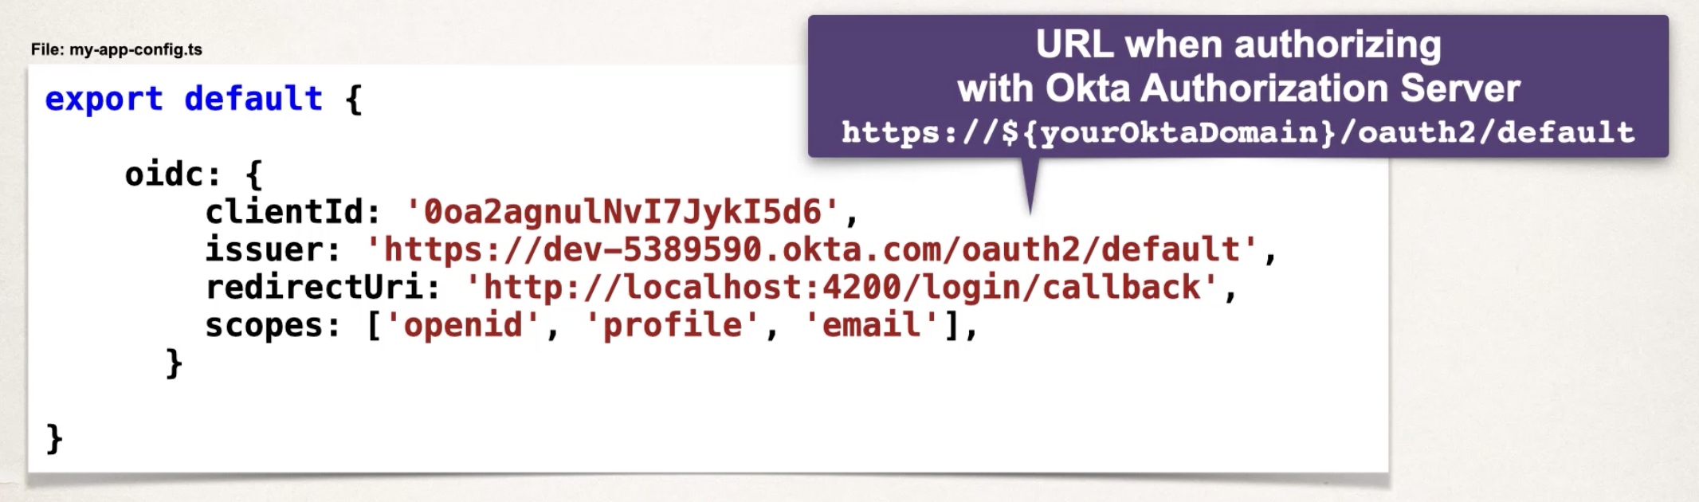
  + 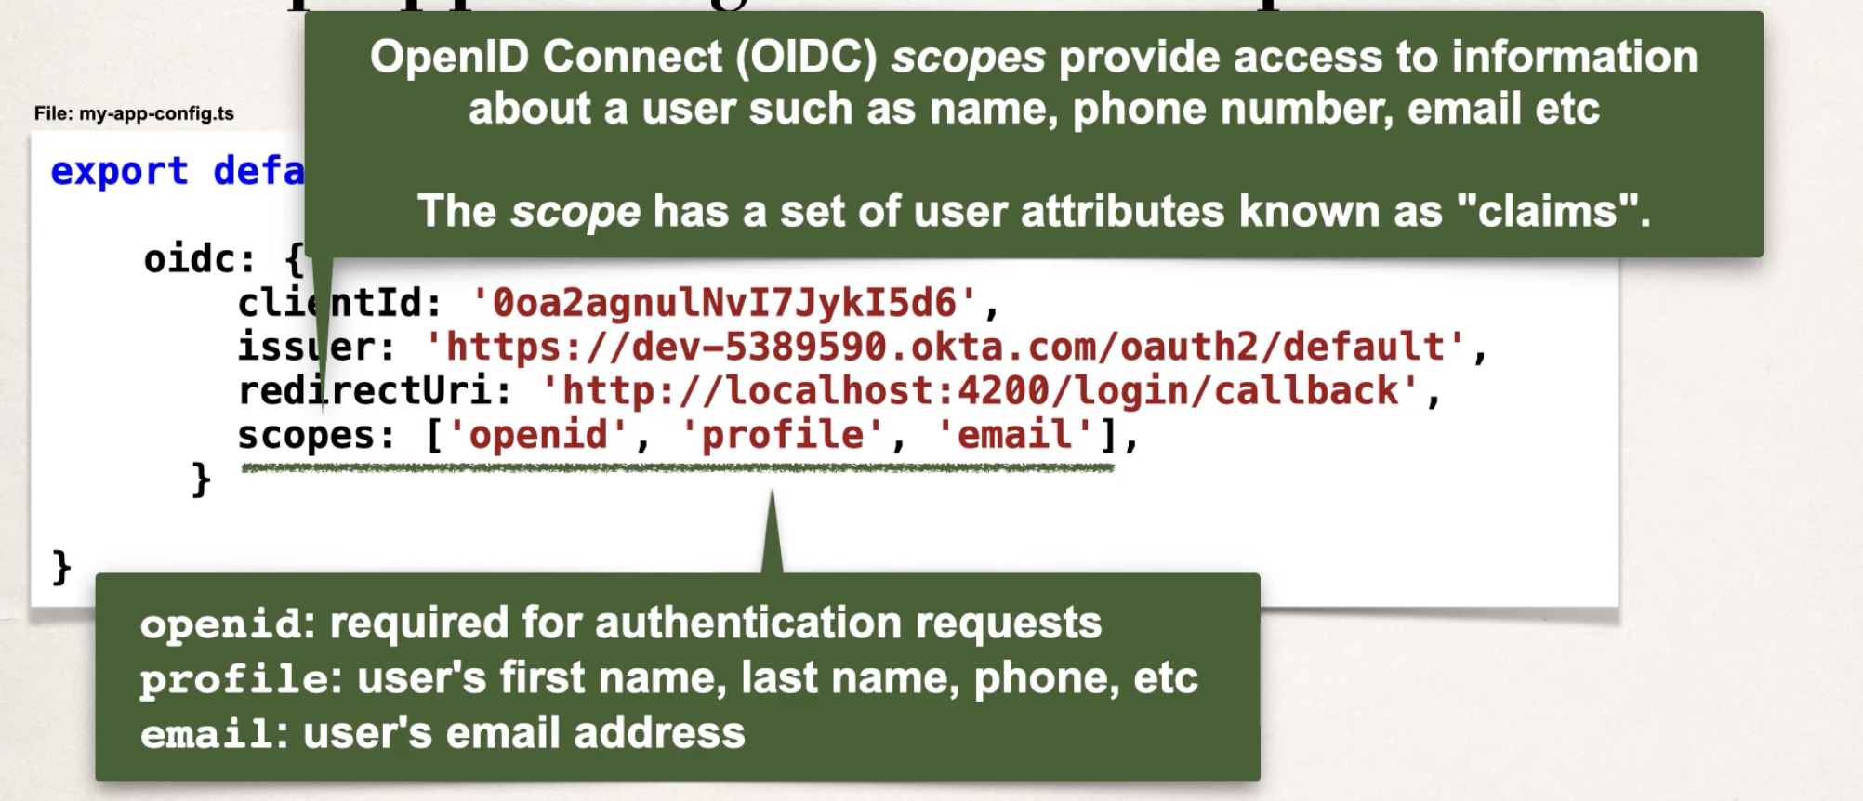
* Install Okta SDK dependencies
  + Okta Sign-In widget
  + Okta React SDK (Software Development Kit)
  + Okta JavaScript SDK
  + 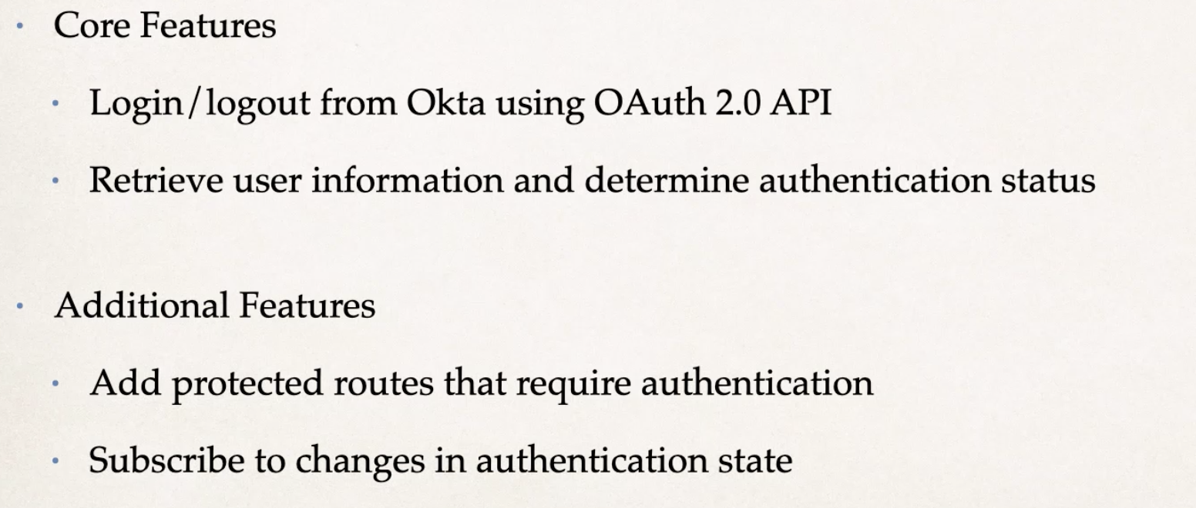
* Integrate Okta Sign-In Widget
  + Src-Auth-LoginWidget.jsx (note: jsx rather than tsx)
  + OktaSignInWidget.jsx
* Add Configurations to our application
* Create new Security Routes & Navigation Login / Logout

Note: Okta does not work. Used Auth0 instead.

Checkout

* Spring boot back end
  + Checkout entity
  + CheckoutRepository
  + New package: service -> new class: BookService
    - checkoutBook function
    - checkoutBookByUser function -> check whether a book has been checked out by user

Security backend – Auth0

* pom.xml add dependencies
* config -> SecurityConfiguration

Security Frontend – Auth0

* lib -> auth0Config.ts
* index.tsx + Auth0Provider and information
* App.tsx + code related to Auth0
* Update Navbar.tsx

JWT

* Extract JWT -> get the test email address from playload
* Make BookController email address dynamic

Make checkout functionality real time

* Layouts -> BookCheckoutPage.tsx -> useEffect for currentLoansCount
* Update CheckoutAndReviewBox.tsx -> add a parameter: currentLoansCount -> make numbers dynamic
* useEffect: is checked out?
* CheckoutAndReviewBox.tsx -> add buttonRender function
* Make signin button dynamic -> e.g., checkout button / already checked out, enjoy!
* Make the check-out button works
  + BookCheckoutPage.tsx -> add checkoutBook() function
  + Update useEffect[]

Review

* Backend
  + Dao -> ReviewRepository -> add review findByUserEmailAndBookId()
  + New package: requestmodels -> new file: ReviewRequest
  + New file: reviewService -> save a review through end point
    - Add a new function to see whether a user has posted a review for this book or not
  + Review Controller: create GetMapping and PostMapping
* Frontend
  + BookCheckoutPage.tsx
    - Add two new useState
    - Add a new useEffect: get a single review for a user
    - Update useEffect[isReviewLeft]
  + CheckoutAndReviewBox.tsx
    - Add parameter: isReviewLeft: Boolean
    - Create a new function: reviewRender
  + Utils -> LeaveAReview.tsx
    - Create a dropdown menu
    - Apply to CheckoutAndReviewBox
  + Models -> ReviewRequestModel
  + BookCheckoutPage – submit review functionality
    - submitReview function
  + layouts -> utils -> LeaveAReview
    - BookCheckoutPage -> ReviewBox

Review List Page

* BookCheckoutPage folder -> ReviewListPage folder
* Copy useEffec from BookCheckoutPage and make some changes
* Add pagination
* Update app.tsx route
* Update LastestReviews

ShelfPage and Loans

* Loans
  + Layouts -> new folder: ShelfPage
  + Add route to App.tsx
    - Make sure the route requires user’s authentication before they get the access of the /shelf page.
  + Endpoint: get date and book for the user
    - New folder: responsemodels
    - New file: ShelfCurrentLoansResponse
    - Service -> BookService: new function: List<ShelfCurrentLoansResponse>
    - Dao -> BookRepository -> create findBooksByBookid function
    - BookController: GetMapping
  + Frontend
    - Models -> ShelfCurrentLoans.ts
    - ShelfPage folder -> new folder: components -> new file: Loans.tsx
      * Desktop
        + Apply to ShelfPage
      * Mobile
        + Copy the code from Desktop part and make some changes
    - Modal
      * ShelfPage -> components -> LoansModal.tsx
* Return book service
  + SpringBoot: BookService -> new function: returnBook
  + Add the endpoint to the BookController
  + React
    - Loans -> new State -> add to useEffect[]
    - Add new async function: returnBook
* Renew the loan
  + Backend
    - bookService: renewLoan
    - bookController
  + FrontEnd
    - Loans.tsx: add new function renewLoan
    - LoansModal
      * Add renewLoan as a parameter into the function
      * Add onClick listener to the button
    - Loans.tsx: update LoansModal tag

History

* Backend
  + Entity -> new Java Class: History
  + Dao -> HistoryRepository
  + Service -> BookService
    - update fields and constructor
    - update returnBook function
* Frontend
  + Models -> HistoryModel
  + Layouts -> ShelfPage -> component -> HistoryPage.tsx
    - State
    - Pagination
    - useEffect
    - IsLoadingHistory
    - httpError
    - CSS & HTML
    - Fix history bug: load everytime user search a book
      * ShelfPage -> new State
      * Update two buttons -> add onClick listeners

Library Services

* Backend
  + Entity -> message
  + Dao -> messageRepository
  + Service -> MessageService
  + Controller -> messagesController
* Frontend
  + Layout -> MessagesPage folder -> MessagesPage.tsx
  + Models -> Messages Model
  + Layout -> MessagesPage -> new folder:components -> PostNewMessage.tsx
    - Added a function: submitnewQuestion
  + Layout -> components -> messages.tsx
    - Add to layouts -> HomePage -> components -> LibraryServices

Admin Services

* ManageLibraryPage
  + Layouts -> ManageLibraryPage folder -> ManageLibraryPage.tsx
  + App.tsx -> Route
  + ManageLibraryPage: add three functions
    - addBookClickFunction()
* Auth0
  + Create admin role
  + Action -> Flow -> Login -> add UserType to Token
* Backend
  + Dao-> MessageRepository -> add: findByClosed
* Frontend
  + Layouts -> ManageLibraryPage -> new folder: components
  + New file: AdminMessages.tsx
  + ManageLibraryPage -> component -> new file: AdminMessage.tsx (note: this is single form, not plural form Message)
* Backend: submit response
  + Requestmodels -> AdminQuestionRequest
  + update MessagesService: putMessage
  + MessagesController
* Frontend
  + Models -> AdminMessageRequest.ts
  + Layouts -> ManageLibraryPage -> components -> AdminMessages.tsx
    - Added new state: btnSubmit
    - Added async function:submitResponseToQuestion
  + AdminMessage.tsx
    - Add new prop: submitResponseToQuestion: any
    - New function: submitBtn

Admin Add New Book Overview

* Backend
  + Requestmodels -> AddBookRequest
  + Service -> AdminService
  + Controller -> AdminController
  + SecurityConfiguration add “/api/admin/secure/\*\*”
* Frontend
  + Models -> AddBookRequest.ts
  + Layouts -> ManageLibraryPage -> components -> AddNewBook.tsx
  + File -> base64 -> sent to SpringBoot
    - Add new function: base64ConversionForImages
    - New function: submitNewBook

Change Quantity

* Frontend
  + manageLibraryPage -> components -> ChangeQuantityOfBooks.tsx
    - copy some code from SearchBooksPage.tsx
    - fill in return ();
  + ManageLibraryPage -> components -> ChangeQuantityOfBook.tsx
* Backend – allow admin user to increase copies available for a specific book
  + Increase book quantity:
    - Service -> AdminService -> new function: increaseBookQuantity
    - Controller -> AdminController PutMapping
  + Decrease book quantity
  + Delete a book: when delete a book, we would also like to delete all the checkoutRepository that has the bookId as a column in the checkout.
    - CheckoutRepository
    - Same thing in ReviewRepositroy
    - Service -> AdminService:
      * add reviewRepository and checkoutRepository
      * add new function deleteBook
    - Controller -> AdminController
* Frontend
  + ChangeQuantityOfBook.tsx: add new function: increaseQuantity
  + decreaseQuantity
  + Delete
    - ChangeQuantityofBooks: add useState
    - Add new function: deleteBook
* Frontend – add Admin tab onto the navbar

Secure communication HTTPS using react

* Generate key and self-signed certificate
  + Use the free utility: openssl
  + Package.json: scripts -> add HTTPS=true
* Create .env file
* Run react app with the key and certificate  
  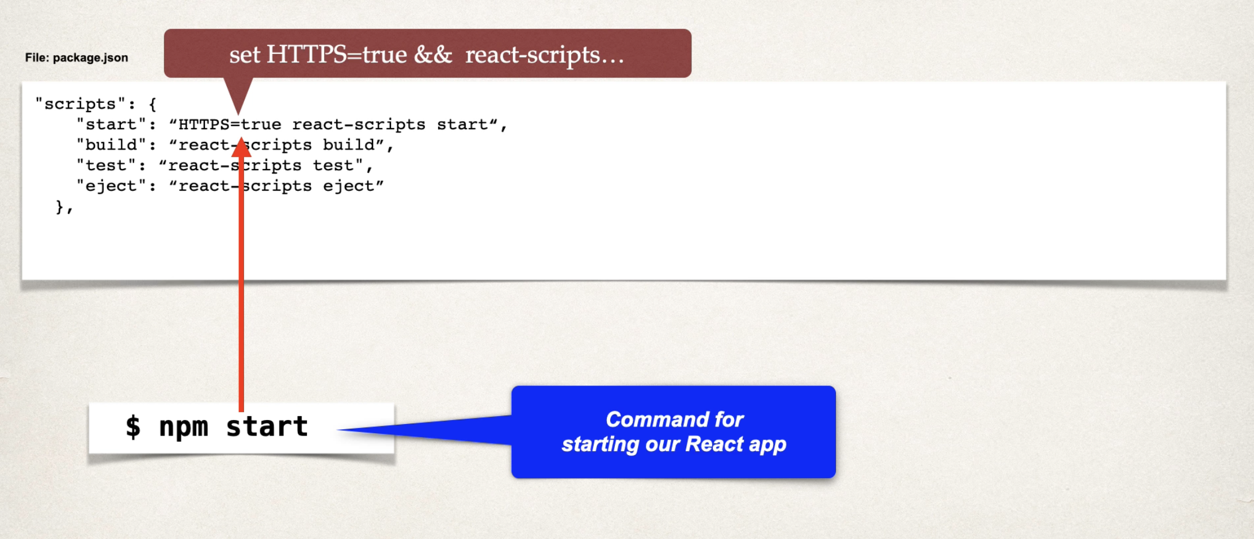
* Update spring book app with new URL
  + MyDataRestConfig
  + Controllers

Update for Auth0

* Update Redirect URI in react app
  + Lib -> auth0Config.ts -> redirectUri: https
* Update Redirect URI in auth0 Dashboard
* Update API trusted origins in auth0 Dashboard

For Java SpringBoot

* Generate key and self-signed certificate
  + Use the JDK utility: keytool  
    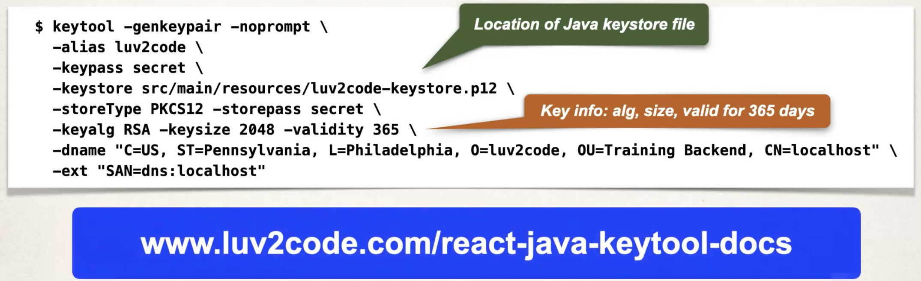
* Update application.properties with security configs
  + 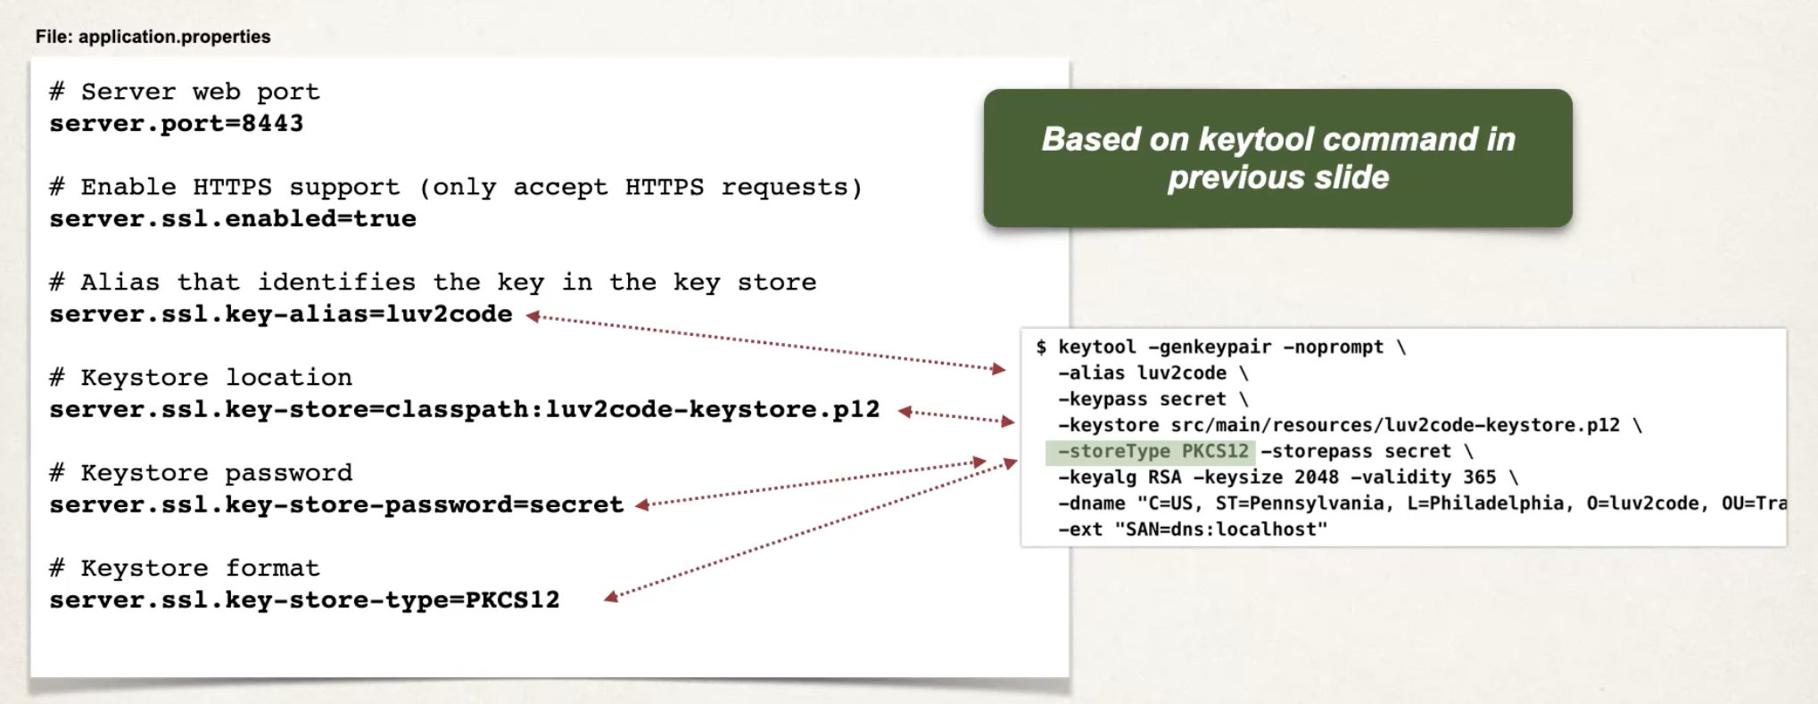
* Java Keystore
  + A file that contains keys and certificates
  + The entries are associated with an alias and pw  
    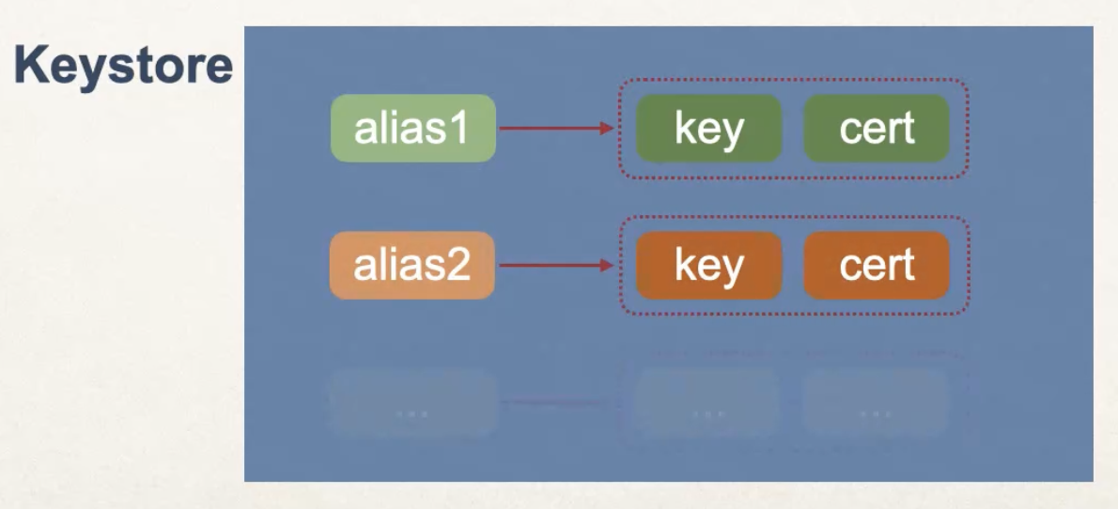

For React: change from 8080 -> 8443

* Instead of hard-coding URL within the components -> replace them in the .env file
  + Add the API endpoint to .env file   
    
  + Add this environmental property to our URLs within our components  
    

Payment

* Payment processing requirement
  + Accept customer credit card info
  + Perform a onetime charge for the late book total  
    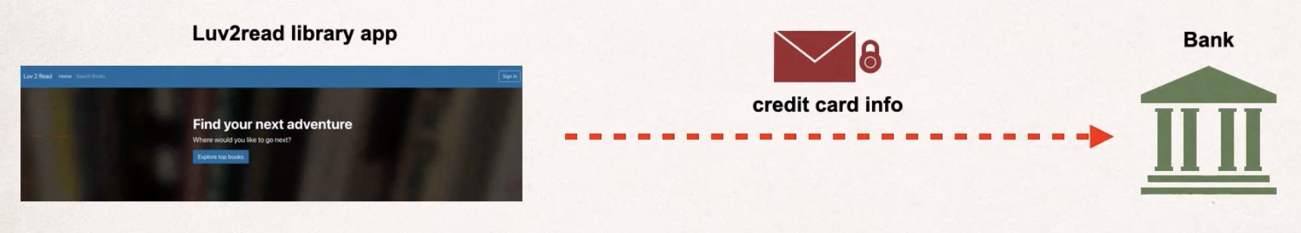
* Payment processors
  + Use an intermediary: a company handles the credit card transaction  
    
  + Stripe: modern API and support many contries
* Stripe integration
  + Stripe API features
    - Online payment processing
    - Invoicing: creating, collecting and reconciling
    - Subscriptions: recurring transactions
    - Quotes: give price estimates for invoices and subscriptions
  + Sensitive Data
    - DevOps must be PCI compliant
    - Payment Card Industry Data Security Standard (PCI DSS)
      * Use and maintain firewalls
      * Proper pw protection
      * Protect card holder data
      * Encrypt transmitted data
      * Use and maintain anti-virus
      * Properly updated software
      * …
    - As a developer:
      * Never send credit data to your own server
      * Never store credit card data on your own server: in memory or DB
  + Stripe integration options
    - Low-code integration: checkout pop-up window
      * Stripe provides a pre-built checkout form  
        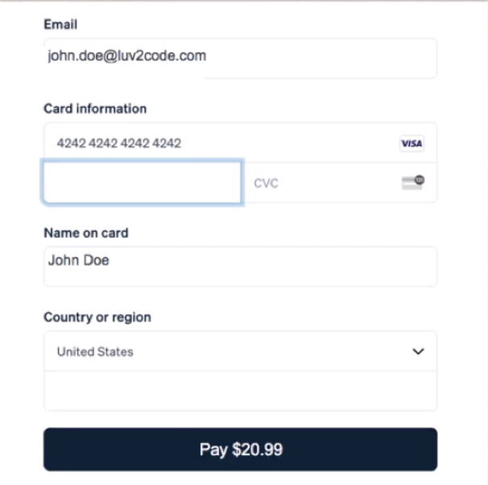
      * Separate pop-up window  
        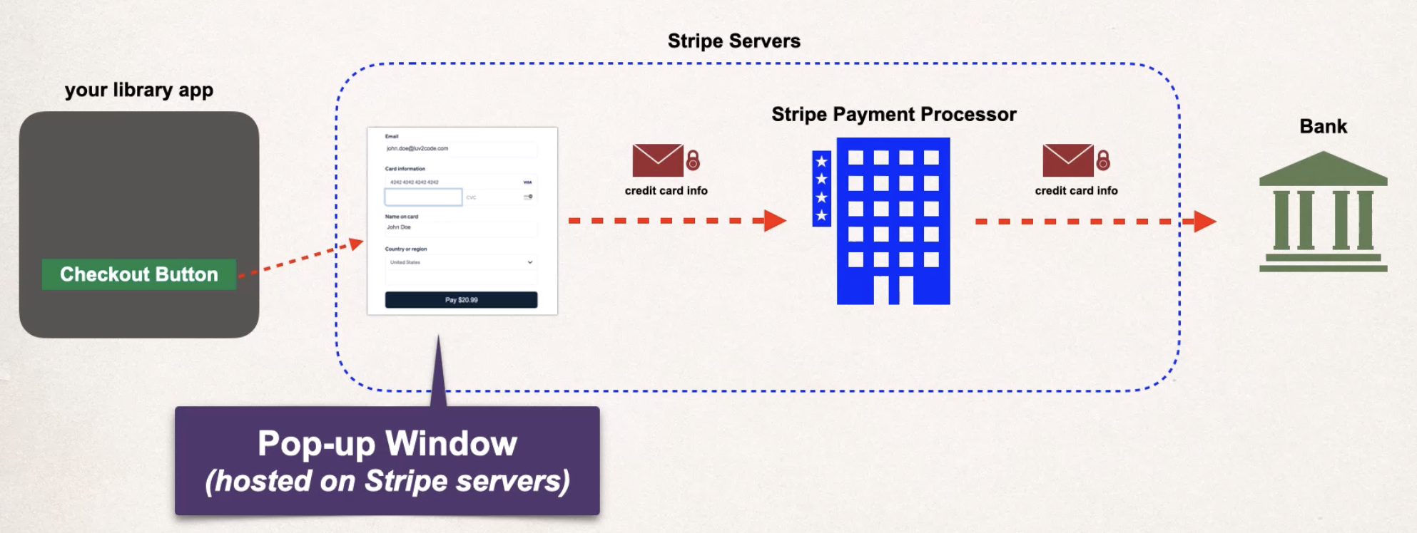
    - Custom code integration: use custom / existing checkout form
      * Stripe Elements  
        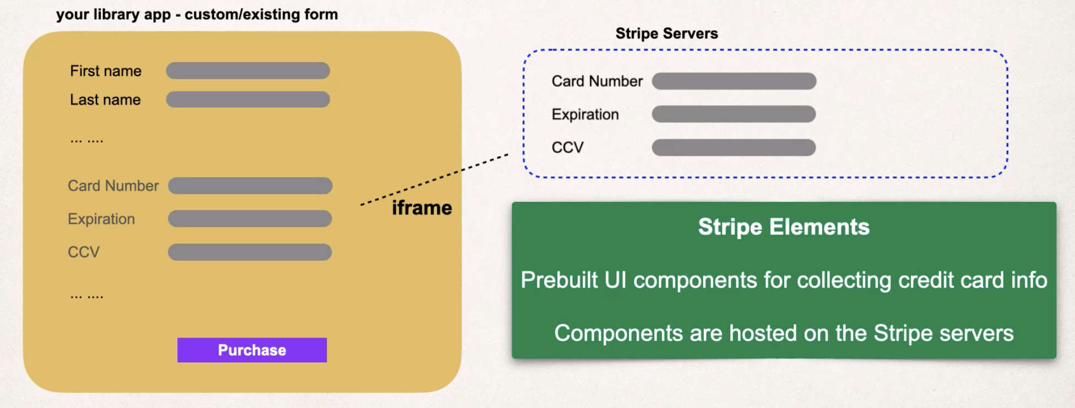  
        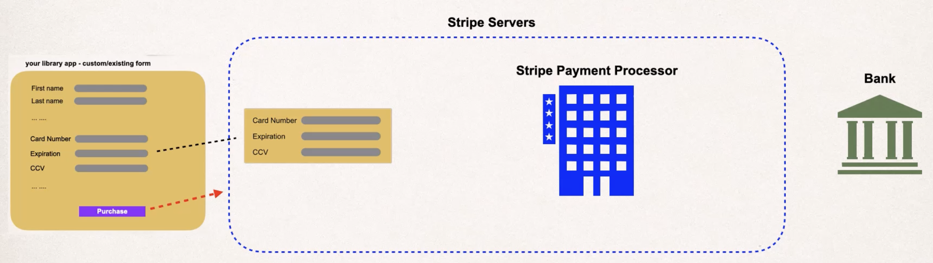
        + Prebuilt UI components for collecting credit card info
        + Hosted on the stripe servers
        + Provide seamless integration
        + Supports PCI
  + Stripe PaymentIntent: the components of a payment
  + Stripe Payment Processing Flow  
    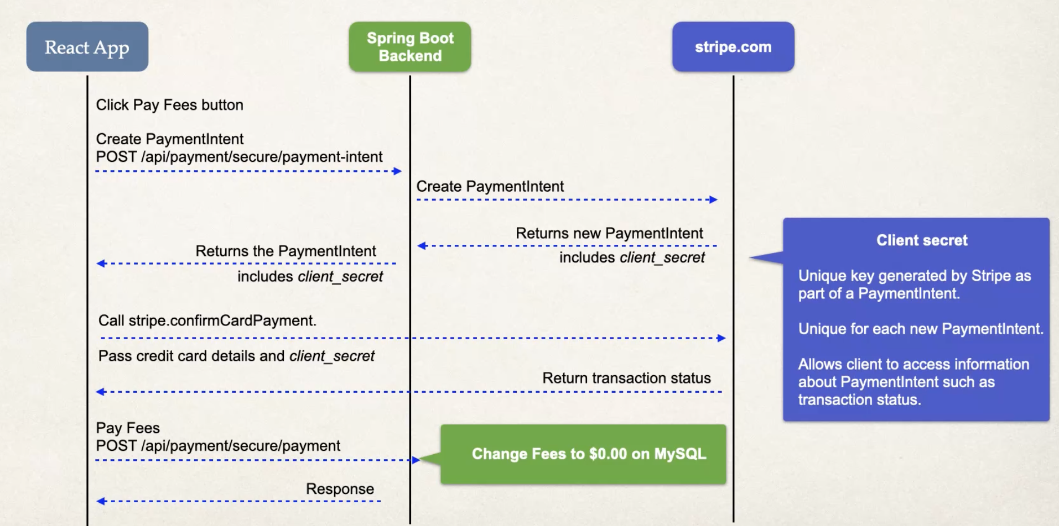
  + Development Process
    - Backend
      * Create stripe dev acct
      * Add stripe Maven Dependency
      * Config Stripe API key
        + Application.properties: add stripe.key.secret
      * Create custom PaymentInfo DTO(Data Transfer Object)
        + Add sql table: payment
        + Entity -> Payment
        + Repository -> paymentRepository
        + Requestmodels -> PaymentInfoRequest
        + Service -> PaymentService -> create PaymentIntent service function
        + Controller -> PaymentController
        + Book service

If a user has book overdue – do not want the user to checkout more books

Add paymentRepository

Update checkoutBook function

Update return book -> collect payment

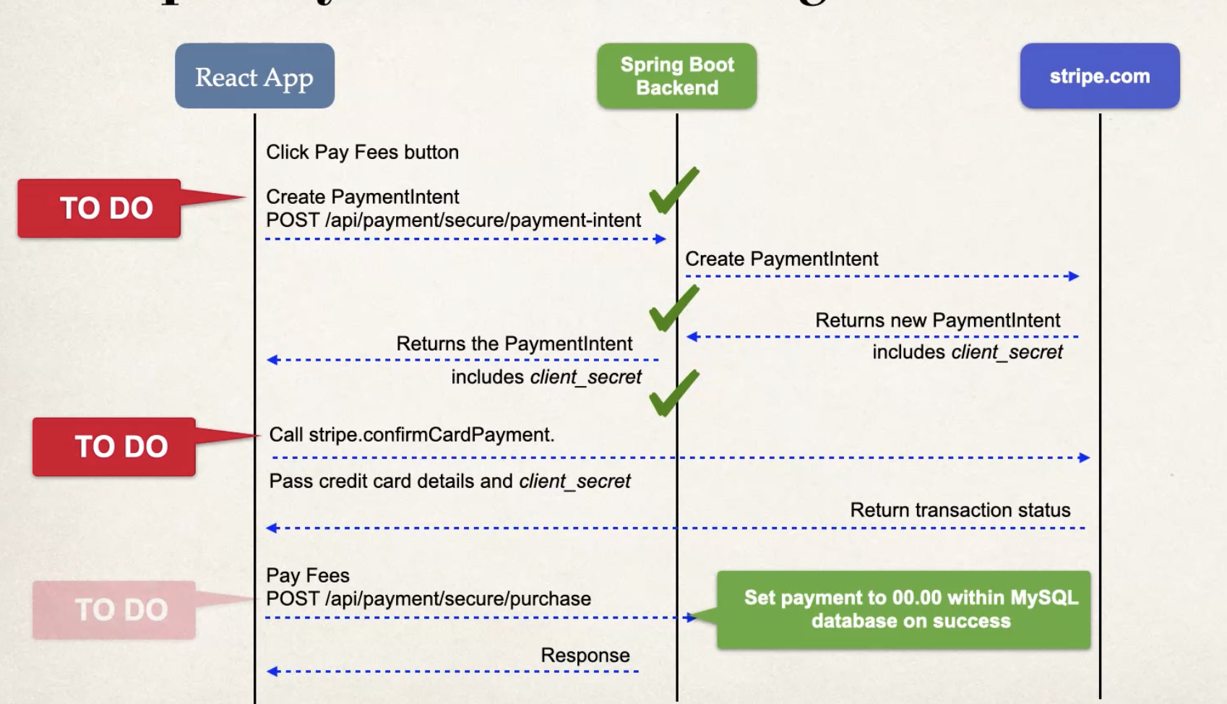

* + - Frontend
      * Install Stripe API
      * Add Stripe script to index.html  
        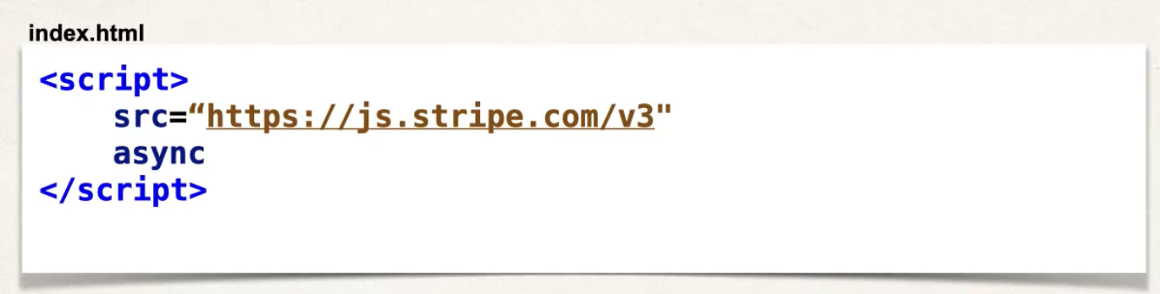
      * Add Stripe published key – from Stripe Developer Dashboard  
        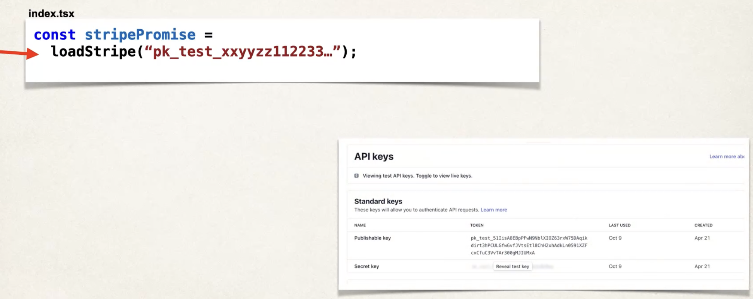
      * Create PaymentInfo DTO
        + Models -> PaymentInfoRequest.ts  
          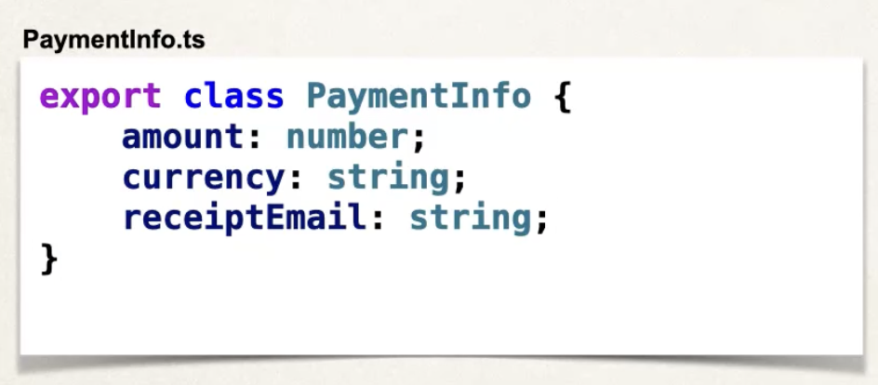
        + Update bookcheckoutPage: don’t allow user to checkout if they have a late book.

New state

Update checkoutBook function

* + - * Create PaymentPage
        + Layout new folder: Paymentpage -> new file PaymentPage.tsx
        + Update app.tsx with secure route
      * Update book checkoutPage: add displayError  
        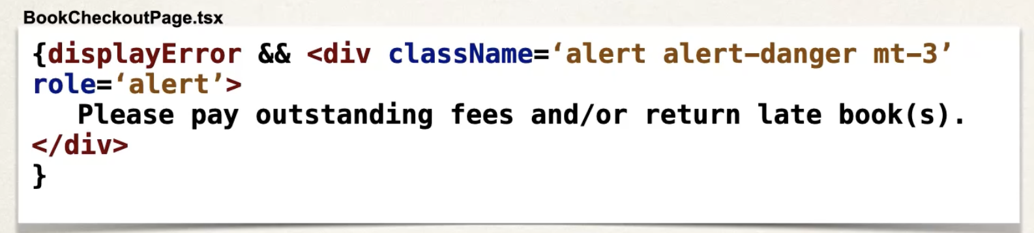
      * Add PayFee button to the navBar